**ADIDAS SALES ANALYSIS**

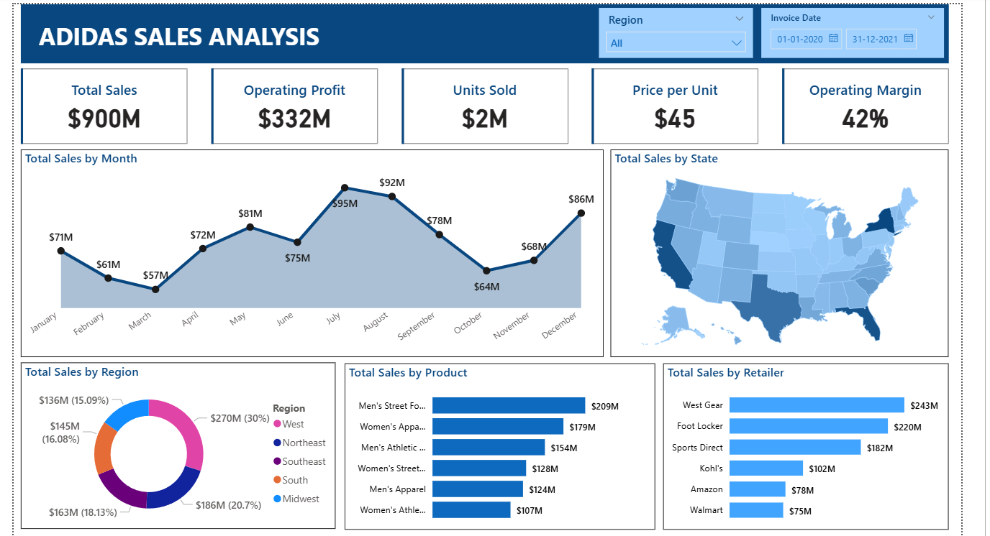

**Key Insights**

**1. Overall Sales Performance**

* **Total Sales:** $900M
* **Operating Profit:** $332M
* **Operating Margin:** 42% (Very strong)
* **Units Sold:** 2M
* **Price per Unit:** $45

Indicates strong profitability and a healthy average unit price.

**2. Monthly Sales Trends**

* **Peak Month:** July ($95M), followed by August ($92M)
* **Lowest Month:** March ($57M), followed by October ($64M)

There's a **mid-year spike** (Q3) and a **dip around Q1 and Q4**.

**Possible cause:** Seasonality, promotions, or product launches.

**3. Regional Sales Distribution**

* **Top Region:** **West** ($270M – 30% of total)
* **Lowest Region:** **Northeast** ($136M – 15%)

**West + Midwest** together contribute **over 50%** of sales.

**4. Product-Wise Sales**

* **Top Product:** Men's Street Footwear ($209M)
* **Next Best:** Women's Apparel ($179M), Men’s Athletic Footwear ($154M)
* **Lowest Product:** Women's Apparel (another category – $107M)

Men's footwear (Street + Athletic) dominates the sales.

**5. Retailer Performance**

* **Top Retailer:** **West Gear** ($243M)
* **Foot Locker** and **Sports Direct** are also strong.
* **Amazon** and **Walmart** contribute **relatively low** ($78M and $75M).

Online/eCommerce sales (Amazon, Walmart) are lower than expected.

**Business Suggestions**

**1. Expand Mid-Year Promotions**

* Leverage the **July–August spike** by planning major product launches or discounts during Q3.

**2. Double Down on High Performers**

* Focus marketing and inventory planning on **Men’s Street Footwear** and **Men’s Athletic Footwear**, as they drive significant revenue.

**3. Improve Sales in Underperforming Regions**

* Target the **Northeast** with regional campaigns, influencer marketing, or local collaborations to boost awareness and demand.

**4. Strengthen eCommerce Channels**

* **Amazon and Walmart** show lower sales; consider:
  + Improving product visibility
  + Running exclusive online promotions
  + Partnering with eCommerce platforms for featured placements

**5. Rethink Low-Selling Product Categories**

* Review the performance and inventory of lower-selling categories like **Women’s Apparel ($107M)**.
  + Consider a revamp in design, pricing, or audience targeting.

**6. Explore Subscription or Loyalty Programs**

* With high unit prices and good operating margins, **repeat purchases** could be incentivized through:
  + Loyalty rewards
  + Exclusive access to new collections
  + Personalized discounts